  RETMAY DISTRIBUTORS, INC.  Industrial Fastener & MRO Supply • Since 1959  “If it’s got a thread, get to Retmay!” | PRODUCT LINE CARD • 2026  Retmay Distributors, Inc.  101 North Cameron Street  Harrisburg, PA 17101  P (717) 232-2433  E Sales@Retmay.com  W retmay.com

INDUSTRIAL FASTENERS • ELECTRICAL • HARDWARE • ABRASIVES • TOOLS • MRO
Serving manufacturers, fleets, OEMs, installers & maintenance teams across all of Pennsylvania (incl. Philadelphia) and New Jersey.

  FASTENERS — PRIMARY LINE
  BOLTS — HEX, CARRIAGE, FLANGE
  NUTS — HEX, NYLOCK, STOVER, WING
  SCREWS — MACHINE, SHEET METAL,
  SELF-DRILLING, SELF-TAPPING
  WASHERS — FLAT, LOCK, FENDER
  SOCKET HEAD CAP SCREWS
  U-NUTS, WELL NUTS, NUTSERTS
  EYE BOLTS, J-BOLTS, U-BOLTS
  RETAINER RINGS & SNAP RINGS
  PINS — COTTER, CLEVIS, DOWEL
  KEYS & KEYSTOCK
  CONCRETE & DRYWALL ANCHORS
  THREADED ROD & STUDS
  GRADE 2, 5, 8 & STAINLESS
  METRIC & SAE / INCH
  ELECTRICAL & WIRE
  PRIMARY & GPT WIRE
  BUTT, BULLET & RING CONNECTORS
  QUICK DISCONNECTS
  WEATHER PACK CONNECTORS
  METRI-PACK CONNECTORS
  TERMINALS — RING, SPADE, FORK
  SNAP SPADE TERMINALS
  HEAT-SHRINK CONNECTORS
  AUTOMOTIVE FUSES — ATC/ATO/MINI
  TOGGLE & ROCKER SWITCHES
  HEAT-SHRINK TUBING
  WIRE LOOM, CABLE TIES
  HARDWARE, CLIPS & TRIM
  PUSH RETAINERS & PUSH-PINS
  CHRISTMAS-TREE FASTENERS
  TRIM PANEL CLIPS & RETAINERS
  MOULDING CLIPS
  WEATHERSTRIP & DOOR CLIPS
  HOLE PLUGS & FLUSH PLUGS
  BODY CLIPS & SPRING CLIPS
  GROMMETS — RUBBER, NYLON,
  INSULATING
  ASSORTMENTS & REFILL KITS
  RIVETS • HOSE CLAMPS • TAPE
  BLIND / POP RIVETS
  CLOSED-END RIVETS
  STRUCTURAL & HUCK-STYLE RIVETS
  ALUMINUM, STEEL & STAINLESS
  WORM-GEAR HOSE CLAMPS
  CRIMP & PINCH CLAMPS
  VACUUM CAPS & CONNECTORS
  ELECTRICAL TAPE
  MASKING & SPLICING TAPE
  DUCT, FOIL & SPECIALTY TAPES
  ABRASIVES & TOOLS
  FLAP WHEELS & FLAP DISCS
  CUT-OFF & GRINDING WHEELS
  SANDING DISCS & BRISTLE DISCS
  SAND PAPER — ROLLS & SHEETS
  HEX BIT & DRIVER SETS
  DRILL BITS — HSS, COBALT, TiN
  TAPS, DIES & THREAD CHASERS
  AWLS, PUNCHES, PRY BARS
  HAND TOOLS & SHOP CONSUMABLES
  SPRINGS, ASSORTMENTS & SPECIALTY
  COMPRESSION & EXTENSION SPRINGS
  TORSION & DIE SPRINGS
  SPRING / ROLL PINS
  SHOP & TECHNICIAN ASSORTMENTS
  FASTENER REFILL KITS
  SPECIALTY & HARD-TO-FIND PARTS
  MADE-TO-PRINT / SOURCED ITEMS
  PRIVATE-LABEL & CUSTOM PACKAGING

RETMAY DISTRIBUTORS, INC.  Since 1959 • Sales@Retmay.com • retmay.com | SERVICES & MANUFACTURER LINES  Custom Kitting • Vendor-Managed Inventory  Serving all of Pennsylvania (incl. Philadelphia) & New Jersey

  CUSTOM KITTING
  Stop building kits in-house. We package your fasteners and components the way your team uses them — saving labor, errors and floor space.
  ▸ Customer-specific fastener kits — built to your bill of materials, assembly, or job.
  ▸ Labeled bags & boxes — bin-tag, part #, count and revision printed on every package.
  ▸ One kit part number to order — replace dozens of line items with a single SKU.
  ▸ Fewer picks & touches — production teams open one bag instead of chasing parts.
  ▸ Cleaner receiving & A/P — one PO line, one receipt, one invoice line per kit.
  ▸ Job-/assembly-ready packaging — sequenced for the work order or model.
  ▸ Private-label options — your part number, your branding.
  VENDOR-MANAGED INVENTORY (VMI)
  We own the headache of keeping your bins stocked. You focus on building, fixing and shipping.
  ▸ Kanban / two-bin stocking — visual triggers at point-of-use; no stockouts, no over-ordering.
  ▸ Bin labeling & part tagging — every bin and shelf clearly identified.
  ▸ Scheduled cycle counts — we walk your floor and count, you keep producing.
  ▸ Min/max planning — usage-driven reorder points refreshed regularly.
  ▸ Just-in-time replenishment — we deliver and re-stock the bins.
  ▸ Single source for fasteners & MRO — fewer vendors, fewer POs.
  ▸ Usage reports — visibility into what you actually consume.

WHO WE SERVE Manufacturers • OEMs • Maintenance & MRO Teams • Fleets • Installers & Contractors • Industrial Buyers

REPRESENTATIVE MANUFACTURER LINES
A top distributor of Champion products in Central Pennsylvania.
  Champion |   Norton |   3M |   Permatex
  Parker |   Huck |   Marson |   Auveco
  Drossbach |   Advanced Cable Ties | 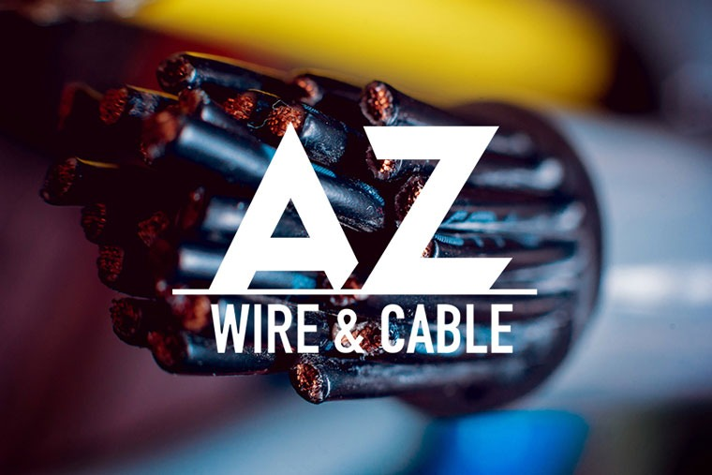  AZ Wire & Cable |   All America Threaded Products

Lines include: Champion • Norton • 3M • Permatex • Parker • Huck • Marson • Auveco • Drossbach • Advanced Cable Ties • AZ Wire & Cable • All America Threaded Products (aatprod.com)
This is a representative listing. If you don’t see what you need, call or email — we source thousands of additional fastener and MRO items.
“IF IT’S GOT A THREAD, GET TO RETMAY!”
Call (717) 232-2433 • Email Sales@Retmay.com • Visit retmay.com
RETMAY DISTRIBUTORS, INC. • 101 N. CAMERON ST., HARRISBURG, PA 17101 • (717) 232-2433 • SALES@RETMAY.COM • RETMAY.COM

